

**WhiteRabbit and   
Rabbit-In-a-Hat User Manual**

Version 1.0

July 2014

Martijn Schuemie & Erica Voss

# Table of Contents

Table of Contents 2

1. WhiteRabbit 3

1.1. Introduction 3

1.1.1. Scope and Purpose 3

1.1.2. Process Overview 3

1.2. Installing 3

1.3. Specifying the Location of Data 4

1.3.1. Working Folder 4

1.3.2. Source Data 4

1.4. Scanning a Database 5

1.4.1. Performing the Scan 5

1.4.2. Reading the Scan 6

1.5. Generating Fake Data 6

2. Rabbit-In-a-Hat 7

2.1. Introduction 7

2.1.1. Scope and Purpose 7

2.1.2. Process Overview 7

2.2. Installing 7

2.3. Getting Started 7

2.3.1. Create a New Document 7

2.3.2. Open an Existing Document 7

2.4. Connecting Source Tables to CDM Tables 8

2.5. Connecting Source Fields to CDM Fields 8

2.6. Generating an ETL Document 9

3. Best Practices 10

4. Document Revision Table 10

# WhiteRabbit

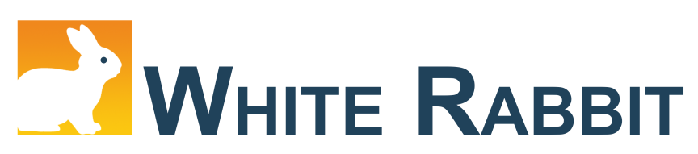

## Introduction

### Scope and Purpose

WhiteRabbit is a software tool to help prepare for ETLs (Extraction, Transformation, Loading) of longitudinal healthcare databases into the Observational Medical Outcomes Partnership (OMOP) Common Data Model (CDM) (<http://omop.org/CDM>). The source data can be in comma-separated text files, or in a database (MySQL, SQL Server, ORACLE, PostgreSQL), the CDM will be in a database (MySQL, SQL Server, PostgreSQL). WhiteRabbit is known not to work with Teradata.

WhiteRabbit’s main function is to perform a scan of the source data, providing detailed information on the tables, fields, and values that appear in a field. This scan will generate a report that can be used as a reference when designing the ETL, for instance by using the Rabbit-In-a-Hat tool. White Rabbit differs from standard data profiling tools in that it attempts to prevent the display of personally identifiable information (PII) data values in the generated output data file.

### Process Overview

The typical sequence for using this software to scan source data in preparation of developing an ETL into an OMOP CDM:

1. Set working folder, the location on the local desktop computer where results will be exported.
2. Connect to the source database or CSV text file and test connection.
3. Select the tables of interest for the scan and scan the tables.
4. WhiteRabbit creates an export of information about the source data.

Once the scan report is created, this report can then be used in the Rabbit-In-a-Hat tool or as a stand-alone data profiling document.

## Installing

WhiteRabbit can be found on GitHub with other Observational Health Data Sciences and Informatics (OHDSI) tools at <https://github.com/OHDSI>. Follow the README.md instructions for downloading the tool to your local environment.

You will need Java to run the tool in your local environment; this can be downloaded from <http://www.java.com>.

## Specifying the Location of Data

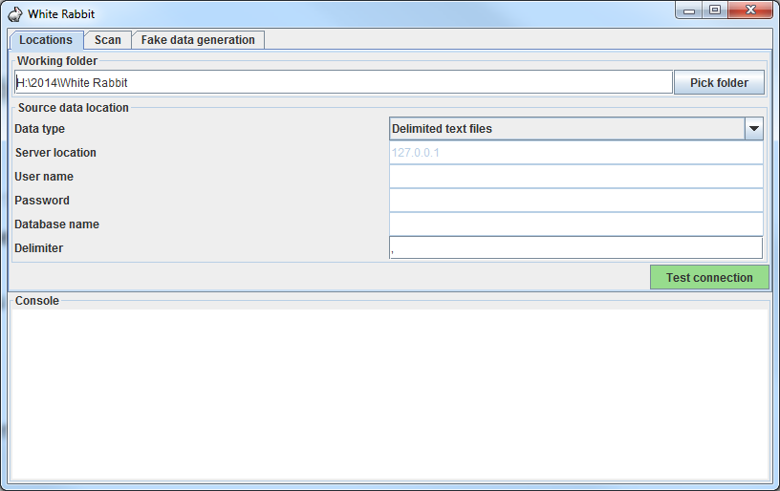

### Working Folder

Any files that WhiteRabbit creates will be exported to this local folder. Use the “Pick Folder” button to navigate in your local environment where you would like the scan document to go.

### Source Data

Here you can specify the location of the source data. The following source types are supported: delimited text files, MySQL, Oracle, SQL Server, and PostgreSQL. Below are connection instructions for each data type of data source. Once you have entered the necessary information, the “Test connection” button can ensure a connection can be made.

**Delimited text files** (source data only)

* ***Delimiter:*** specifies the delimiter that separates columns, default is ‘,’ and your can write ‘tab’ for tab delimited.

WhiteRabbit will look for the files to scan in the same folder you set up as a working directory.

**MySQL**

* ***Server location:*** the name or IP address of the server running MySQL
* ***User name:*** name of the user used to log into the server
* ***Password:*** password for the supplied user name
* ***Database name:*** name of the database containing the tables

**Oracle**

* ***Server location:*** this field contains the SID, service name, and optionally the port: '<host>/<sid>', '<host>:<port>/<sid>', '<host>/< service name >', or '<host>:<port>/<service name>'
* ***User name:*** name of the user used to log into the server
* ***Password:*** password for the supplied user name
* ***Database name:*** this field contains the schema (i.e. 'user' in Oracle terms) containing the tables

**SQL Server**

* ***Server location:*** the name or IP address of the server running SQL Server
* ***User name:*** name of the user used to log into the server. Optionally, the domain can be specified as <domain>/<user> (e.g. 'MyDomain/Joe')
* ***Password:*** password for the supplied user name
* ***Database name:*** name of the database containing the tables

When the SQL Server JDBC drivers are installed, you can also use Windows authentication. In this case, user name and password should be empty.

* 1. Download the .exe from <http://msdn.microsoft.com/en-us/sqlserver/aa937724.aspx>.
  2. Run it, thereby extracting its contents to a folder.
  3. In the extracted folder you will find the file *sqljdbc_4.0/enu/auth/x64/sqljdbc_auth.dll* (64-bits) or *sqljdbc_4.0/enu/auth/x86/sqljdbc_auth.dll* (32-bits), which needs to be moved to a location on the system path, for example to *c:/windows/system32*.

**PostgreSQL**

* ***Server location:*** this field contains the host name and database name (<host>/<database>)
* ***User name:*** name of the user used to log into the server
* ***Password:*** password for the supplied user name
* ***Database name:*** this field contains the schema containing the source tables

## Scanning a Database

### Performing the Scan

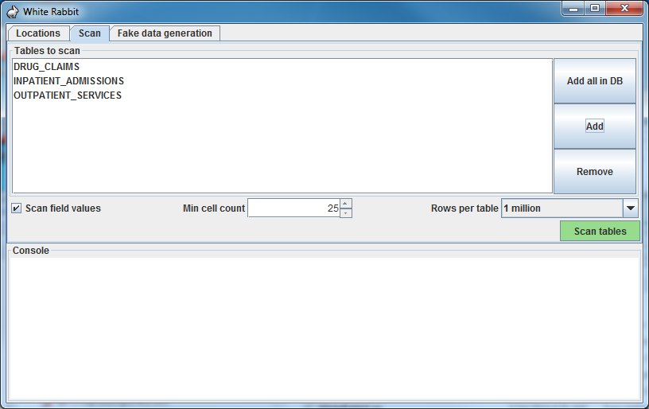

A scan generates a report containing information on the source data that can be used to help design the ETL. Using the Scan tab in WhiteRabbit you can either select individual tables in the selected source database by clicking on ‘Add’ (Ctrl + mouse click), or automatically select all tables in the database by clicking on ‘Add all in DB’.

There are a few setting options as well with the scan:

* Checking the “Scan field values” tells WhiteRabbit that you would like to investigate raw data items within tables selected for a scan (i.e. if you select Table A, WhiteRabbit will review the contents in each column in Table A).
  + “Min cell count” is an option when scanning field values. By default this is set to 25, meaning values in the source data that appear less than 25 will not appear in the report.
  + “Rows per table” is an option when scanning field values. By default, WhiteRabbit will random 1 million rows in the table. There are other options to review 100,000 or all rows within the table.
* Unchecking the “Scan field values” tells WhiteRabbit to not review or report on any of the raw data items.

Once all settings are completed, press the “Scan tables” button. After the scan is completed the report will be written to the working folder.

### Reading the Scan

After the scan is completed, a “ScanReport” Excel document will be created in the working folder location selected earlier. The document will have multiple tabs, one as an “Overview” and then one tab for each database table or delimited text files selected for the scan. The “Overview” tab will tell you about each table selected, what the columns in each table are, the data type of the columns, the amount of data within the table, the number of rows scanned, and the fraction of data empty. Below is an example image of the “Overview” tab. Column A will list what table the information is about, Column B the column being reviewed, Column C, the type of the column, Column E is the number of rows (however with text files it will return -1), Column F will tell you how many rows of the N rows were reviewed, and Column G will let you know how many rows are empty.

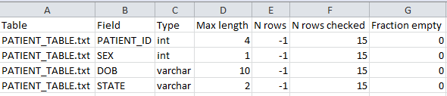

For a tab that describes a single table, the columns names from the source table (or delimited text file) will be across the columns of the Excel tab. Each source table column will generate two columns in the Excel. One column will list all distinct values that have a “Min cell count” greater than what was set at time of the scan (Section 1.4.1). If a list of unique values was truncated, the last value in the list will be “List truncated”; this indicates that there are one or more additional unique source values that appear less than the number entered in the “Min cell count” described in Section 1.4.1. Next to each distinct value will be a second column that contains the frequency, or the number of times that value occurs in the data. These two columns (distinct values and frequency) will repeat for all the source columns in the table profiled in the workbook.

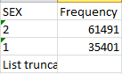

The report is powerful in understanding your source data by highlighting what exists. For example, if the following results were given back on the “SEX” column within one of the tables scanned, we can see that there were two common values (1 and 2) that appeared 61,491 and 35,401 times respectively. WhiteRabbit will not define 1 as male and 2 as female; the data holder will typically need to define source codes unique to the source system. However these two values (1 & 2) are not the only values present in the data because we see this list was truncated. These other values appear with very low frequency (defined by “Min cell count”) and often represent incorrect or highly suspicious values. When generating an ETL we should not only plan to handle the high-frequency gender concepts 1 and 2 but the other low-frequency values that exist within this column.

## Generating Fake Data

This feature allows one to create a fake dataset based on a WhiteRabbit scan report. This dataset could be used to develop ETL code when direct access to the data is not available.

This feature is currently still experimental.

# Rabbit-In-a-Hat

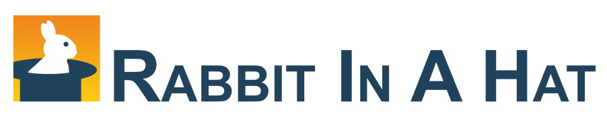

## Introduction

### Scope and Purpose

Rabbit-In-a-Hat comes with WhiteRabbit and is designed to read and display a WhiteRabbit scan document. WhiteRabbit generates information about the source data while Rabbit-In-a-Hat uses that information and through a graphical user interface to allow a user to connect source data to tables and columns within the CDM. Rabbit-In-a-Hat generates documentation for the ETL process it does not generate code to create an ETL.

### Process Overview

The typical sequence for using this software to generate documentation of an ETL:

1. Scanned results from WhiteRabbit completed
2. Open scanned results; interface displays source tables and CDM tables
3. Connect source tables to CDM tables where the source table provides information for that corresponding CDM table
4. For each source table to CDM table connection, further define the connection with source column to CDM column detail
5. Save Rabbit-In-a-Hat work and export to a MS Word document.

## Installing

Follow steps above for installing WhiteRabbit. Follow the README.md instructions to launch Rabbit-In-a-Hat.

## Getting Started

### Create a New Document

To create a new document, navigate to *File🡪Open Scan Report*. Use the “Open” window to browse for the scan document created by WhiteRabbit. When a scan document is open, the tables scanned will appear in orange boxes on the “Source” side of the Tables.

Save the Rabbit-In-a-Hat document by going *File🡪Save as*.

### Open an Existing Document

To open an existing Rabbit-In-a-Hat document use *File🡪Open ETL specs.*

## Connecting Source Tables to CDM Tables

It is assumed that the owners of the source data should be able to provide detail of what the data table contains, Rabbit-In-a-Hat will describe the columns within the table but will not provide the context a data owner should provide. For the CDM tables, if more information is needed navigate to the OMOP CDM web page (<http://omop.org/CDM>) and review the current OMOP specification.

To connect a source table to a CDM table, simply hover over the source table until an arrow head appears.

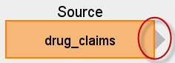

Use your mouse to grab the arrow head and drag it to the corresponding CDM table. In the example below, the *drug_claims* data will provide information for the *drug_exposure* table.

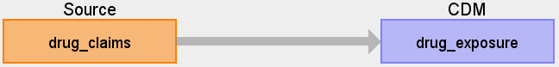

If you click on the arrow once it will highlight and a *Details* window will appear in the right pane. Use this to describe *Logic* or *Comments* that someone developing the ETL code should know about this source table to CDM table mapping.

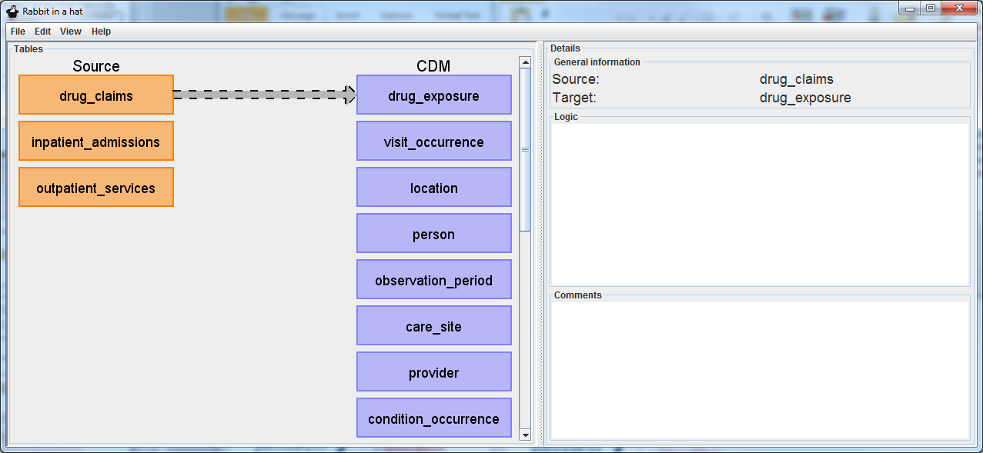

Continue this process until all tables that are needed to build a CDM are mapped to their corresponding CDM tables. One source table can map to multiple CDM tables and one CDM table can receive multiple mappings. There may be tables in the source data that should not be map into the CDM and there may be tables in the CDM that cannot be populated from the source data.

## Connecting Source Fields to CDM Fields

By double clicking on an arrow connecting a source and CDM table, it will open a *Fields* pane below the arrow selected. The *Fields* pane will have all the source table and CDM fields and is meant to make the specific column mappings between tables. Hovering over a source table will generate an arrow head that can then be selected and dragged to its corresponding CDM field. For example, in the *drug_claims* to *drug_exposure* table mapping example, the source data owners know that *patient_id* is the patient identifier and corresponds to the *CDM.person_id.* Also, just as before, the arrow can be selected and *Logic* and *Comments* can be added.

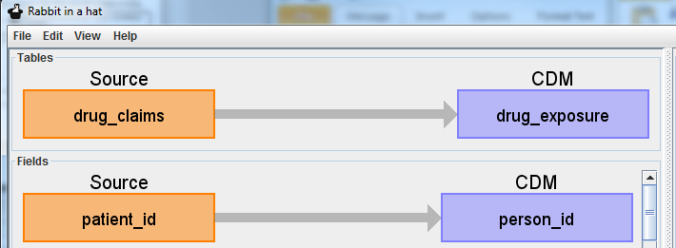

If you select the source table orange box, Rabbit-In-a-Hat will expose values the source data has for that table. This is meant to help in the process in understanding the source data and what logic may be required to handle the data in the ETL. In the example below *ndcnum* is selected and raw NDC codes are displayed starting with most frequent (note that in the WhiteRabbit scan a “Min cell count” could have been selected and values below that frequency will not show).

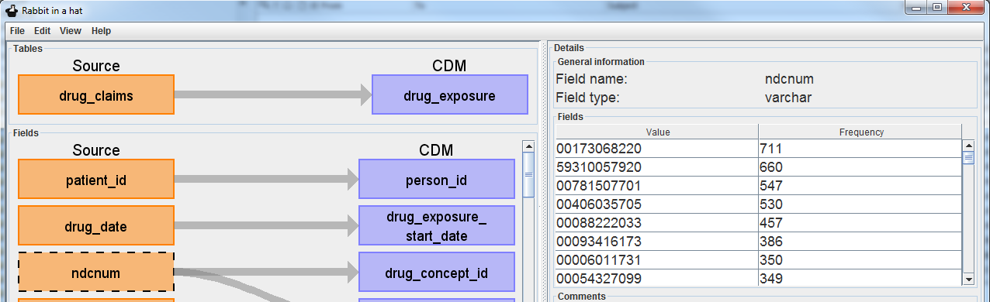

Continue this process until all source columns necessary in all mapped tables have been mapped to the corresponding CDM column. Not all columns must be mapped into a CDM column and not all CDM columns require a mapping. One source column may supply information to multiple CDM columns and one CDM column can receive information from multiple columns.

## Generating an ETL Document

To generate an ETL MS Word document use *File🡪Generate ETL document* and select a location to save. It may take a moment before the document is finished creating. This document will contain all notes from Rabbit-In-a-Hat.

Once the information is in the document, if an update is needed you must either update the information in Rabbit-In-a-Hat and regenerate the document or update the document. If you make changes in the document, Rabbit-In-a-Hat will not read those changes and update the information in the tool. However it is common to generate the document with the core mapping information and fill in more detail within the document.

Once the document is completed, this should be shared with the individuals who plan to implement the code to execute the ETL.

# Best Practices

The following lists best practices in using WhiteRabbit and Rabbit-In-a-Hat to manage your ETL documentation process:

* ***Overall Process:***
  + When going through the ETL exercise, it is critical to get all key stakeholders in the room such as the data owners and individuals who plan to perform/manage research using the CDM. We have found different stakeholders have different perspectives on source data and the conversation that occurs improves the ETL process.
* ***WhiteRabbit:***
  + If it is known some tables will not be needed from the source data, do not include them in the scan. If there is a question to if the table is necessary it is better to include it.
* ***Rabbit-In-a-Hat:***
  + Start with mapping tables to tables and then dive into how one table’s fields map into CDM fields. In other words, stay at the table level until all tables a mapped, and then start to map fields.
  + If your source data does not contain certain information you do not need to impute or generate information to fulfil a CDM requirement. For example, if your source data does not contain an end date for when a medication was stopped you do not need to population the DRUG_EXPOSURE.DRUG_EXPOSURE_START_DATE column.
  + Derived CDM tables, like DRUG_ERA, typically will not receive a mapping from the source data because they are generated off the CDM table (in this case DRUG_ERA is generated off DRUG_EXPOSURE).

# Document Revision Table

| **Date** | **Author** | **Change Descriptions** |
| --- | --- | --- |
| 07/17/2014 | Erica Voss | Document created. |